**44-560 Advanced Topics in Database Systems**

**Assignment-09: Data Warehousing**

1. Construct a star schema for a book borrowing scenario at the B. D. Owen’s library.

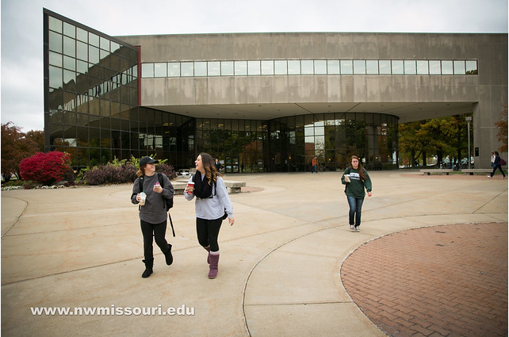

The relevant dimensions and attributes are:

* **Patron_Dim**ension - Attributes: Patron_ID, Patron_Name, Patron_Type, Birthday, Occupation, and Gender.
* **Book_Dim**ension. - Attributes: Book_ID, Edition_Number, Subject, Material_Type, Bar_Code_Type, Title, Author, Classification, Language, Location.
* **Date_Dim**ension. - Attributes: Date_ID, Hour, Day, Week, Month, Year.

The only fact to be recorded is the number of books borrowed.

The library possess approximately 50,000 books and there are 7,000 patrons for the library. On an average, each patron borrows around 1000 books. On any given day, every patron borrows approximately 20 different books. Data must be stored for 12 years.

For the problems below, assume the average field size is 20 bytes.

* 1. Place your star schema in the space below. Remember to use surrogate keys for the primary keys of your dimension tables.

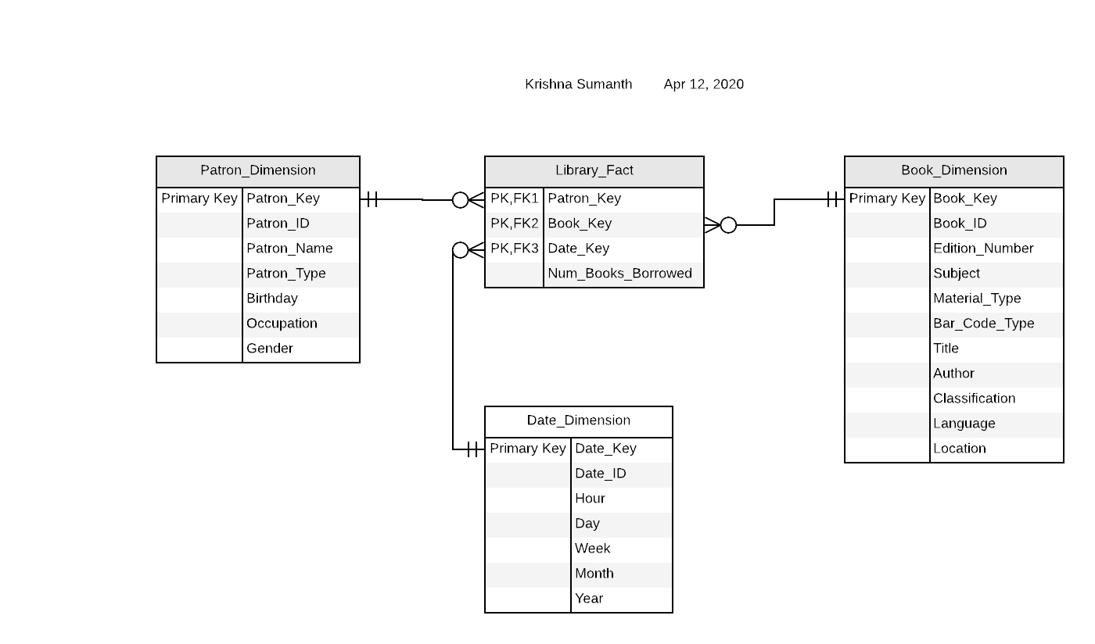

* 1. How many rows will the **Patron_Dim**ension table contain?

Ans. Patron_Dimension table contains 7000 rows.

* 1. Find the size (in bytes) of **Patron_Dim**ension.

Ans. Avg size of attribute is 20 bytes.

Each row has 7 attributes.

Row size = 20*7 = 140 bytes.

Size of Patron_Dimension = 7,000 * 140 = 980,000 bytes.

* 1. How many rows will the **Book_Dim**ension table contain?

Ans. Book_Dimension table contains 50,000 rows.

* 1. Find the size (in bytes) of **Book_Dim**ension.

Ans. Avg size of attribute is 20 bytes.

Each row has 11 attributes.

Row size = 20*11 = 220 bytes.

Size of Patron_Dimension = 50,000 * 220 = 11,000,000 bytes.

* 1. How many rows will the **Date_Dim**ension table contain?

Ans. One row per day for 12 years. So, 365 * 12 = 4,380 rows.

* 1. Find the size (in bytes) of **Date_Dim**ension.

Ans. Avg size of attribute is 20 bytes.

Each row has 7 attributes.

Row size = 20*7 = 140 bytes.

Size of Patron_Dimension = 4,380* 140 = 613,200 bytes.

* 1. How many rows will the fact table contain when all 12 years of data has been stored?

Ans. 7,000 * 4,380 * 20 = 613,200,000.

* 1. Find the size (in bytes) of the fact table when all 12 years of data has been stored.

Ans. 613,200,000 * 80 = 49,056,000,000.

**To submit:**

* Type your answers in the space provided for each question and highlight the answers in yellow.
* Change the filename to Lastname_Assign09.docx and submit the word document.